Lesson 6 – AI Builder and Teams with SAP



Exercise 12: Create a Power App to Display PO data 2
Exercise 13: Shape the data returned from SAP 15
Exercise 14: Embed Power App into Teams (OPTIONAL ) 35

Exercise 12: Create a Power App to Display PO data
We are now ready to create our Power App that can consume the PO Data from SAP. We want to create the Power App inside our existing solution.
- Click Solutions in the left-hand menu and select your SAP Workshop – XX solution.

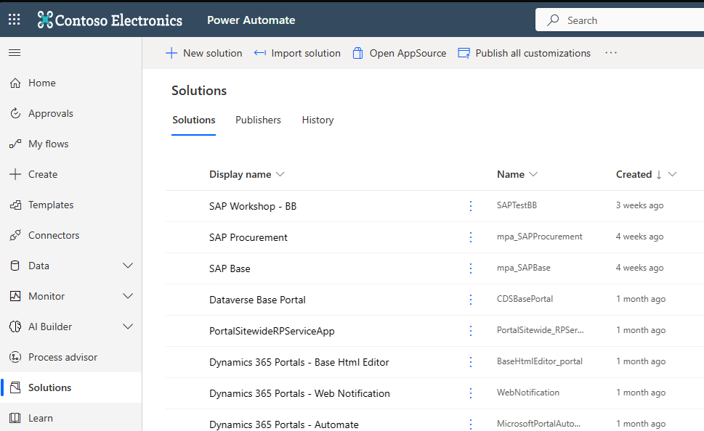

- Create a Canvas App. Click on + New, App, then Canvas App.
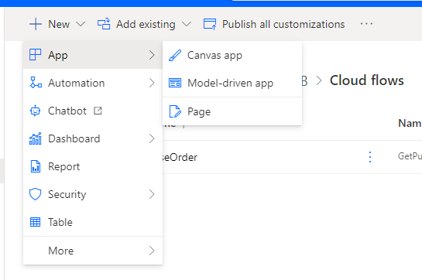

- Type in PurchaseOrderViewer_XX for the App Name where XX are your initials, keep Tablet for the format and then click on Create.

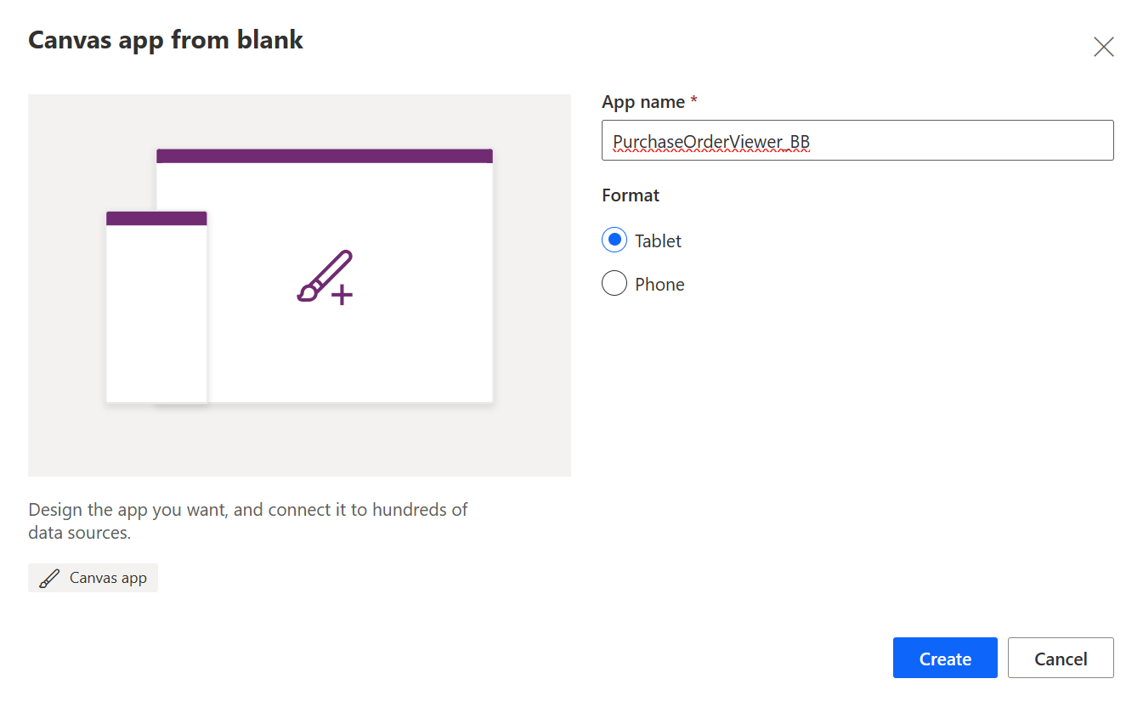
- Click on Skip if you get the Welcome to Power Apps Studio message.
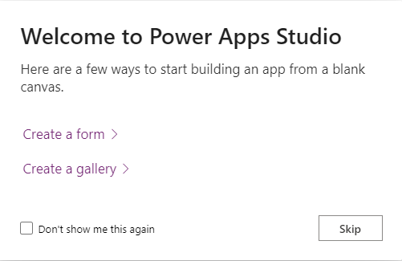
- We need to create a Button and Text Input for initiating the flow based on a PO entered by the user. In the upper ribbon, click on Insert and then Button. Click on Insert again and select the Text Input.
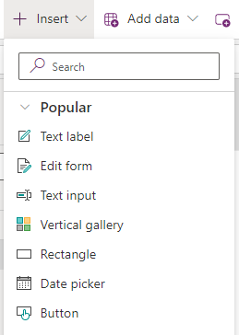

- Drag and Drop the button and the Text Input so they are lined up horizontally in the upper left-hand corner of the screen to match the screen shot below.
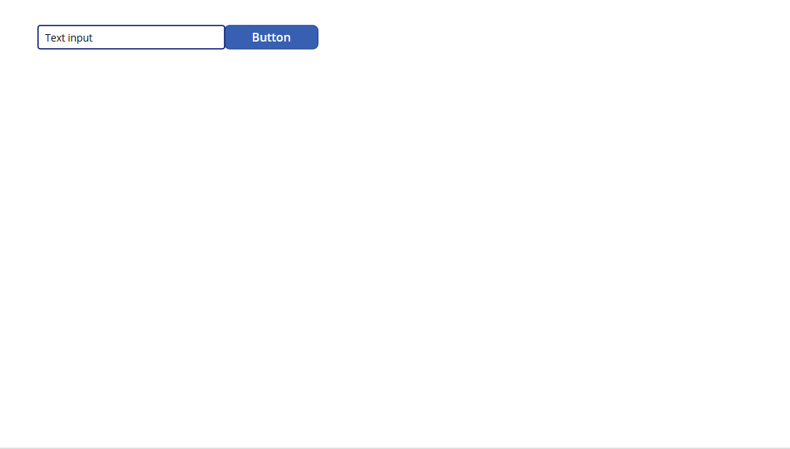
- Change properties of the Button. Click on the Button on the canvas to select it. On the right-hand side, mouse over the name Button1 and then click on the pencil icon to rename to btnGetPOButton. In the Text Box, type Get PO.
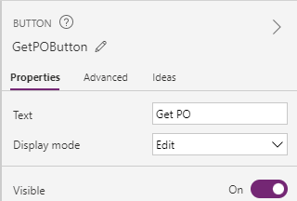

- Change properties of the Text Input. Click on the Text Input box on the canvas to select it. On the right-hand side, click on the pencil icon to rename to tiPO_Input. Delete the value in the Default. Type Enter PO number in the Hint text. (If you don’t see Hint text in the right-hand menu, use the Property dropdown on the left-hand side to modify.)
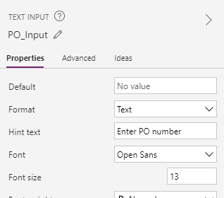
Your canvas should now look like the screen shot below.
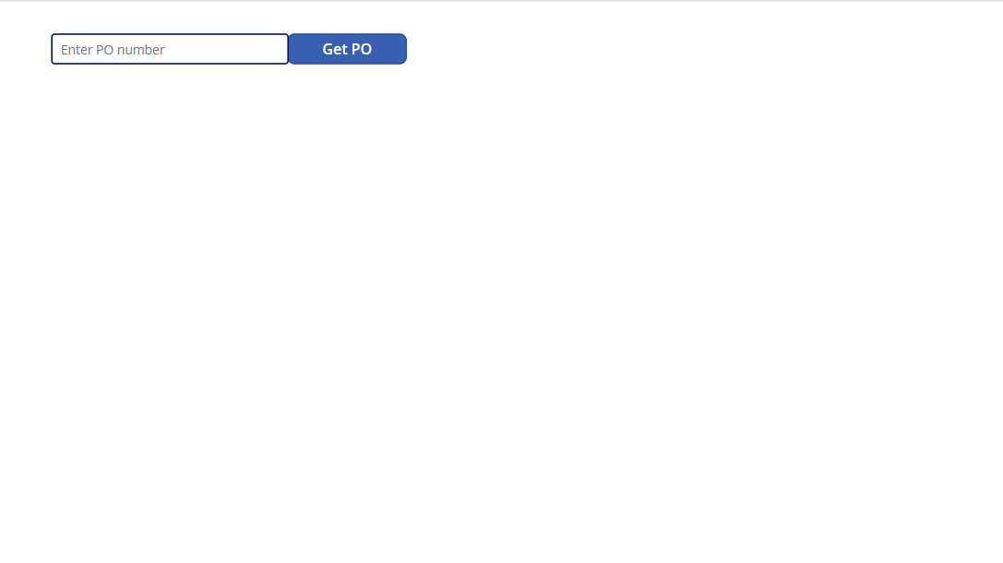
- Connect the Flow we created in the last exercises to this Power App. On the left-hand tree view, click on the Power Automate icon. 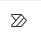
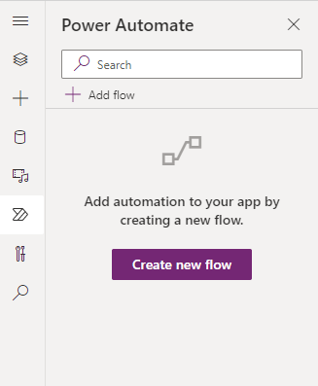

- Click on + Add Flow. Search for GetPurchase and then select GetPurchaseOrder flow.
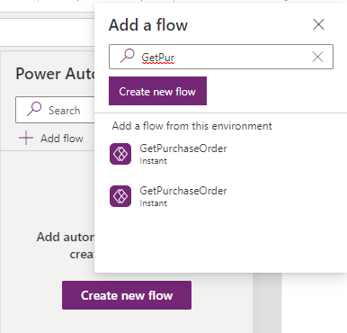
The flow is now in your application and is ready to use.

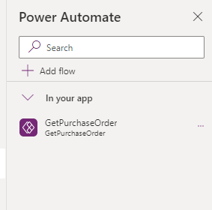

- Configure the button to call the flow with the text input. On the canvas, click on the button to select it. In the upper ribbon, the OnSelect property is selected. Delete False from the Formula bar and start typing GetPurchase. You will see Intellisense pop up the Run Command.
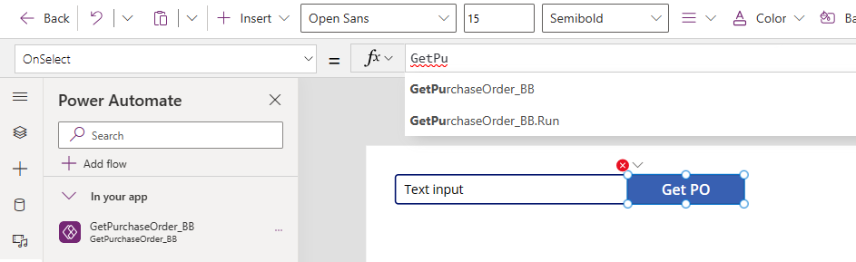
Select the GetPurchaseOrder.Run command. You will see information above the formula bar to guide you on what variables the flow is expecting.
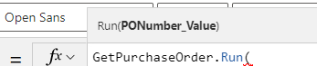
We want to pass the PO number that was typed in by the user in the Text Input box, so type tiPO_Input.Text as the variable and then close the parenthesis.
You will see Intellisense helping out again as you start typing.

- Create a variable to store the PO information. We will be modifying the OnSelect formula for the button. Click on the Home key to bring the cursor back to the front of the formula. Hit the space bar to unselect GetPurchaseOrder. Type in Set(POData, in front of your formula and then a final close parenthesis at the end. The final formula should look like the screen shot below. This will create a variable called POData to store all the information that comes back from our flow.
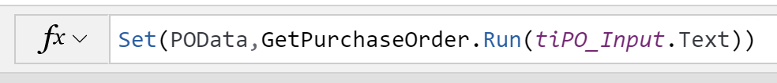
- Save and Test the App. Click on the Save button and then click on the Play button in the upper right of the ribbon.
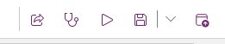
- Type our sample PO number into the text box – 4500019716 – and click on the Get PO Button. You should see some dots across the top of the screen as the flow is running. The flow is complete when the GetPO button is blue again.
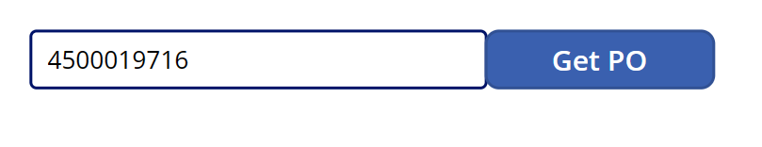
Click the X in the upper right-hand corner to close playing the app.
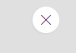
- Verify there is data in our POData Variable. Click on the GetPO Button to select and then double click on the POData variable in our formula bar. We see that we now have a record associated called Header.

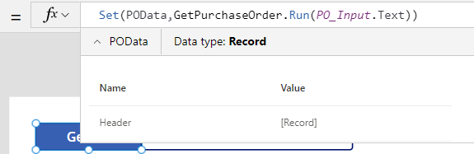

- We will now modify the app to create places for the SAP PO Header Data to show up in the app. Click Insert and select Text label. Repeat this so there are (2) new Text labels on the canvas.

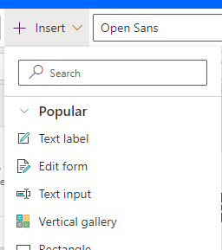

- Configure the Text Labels. Drag and drop the labels so they are lined up vertically on the left-hand side of the canvas under the GetPO Button. Your canvas should look like the screen shot below.
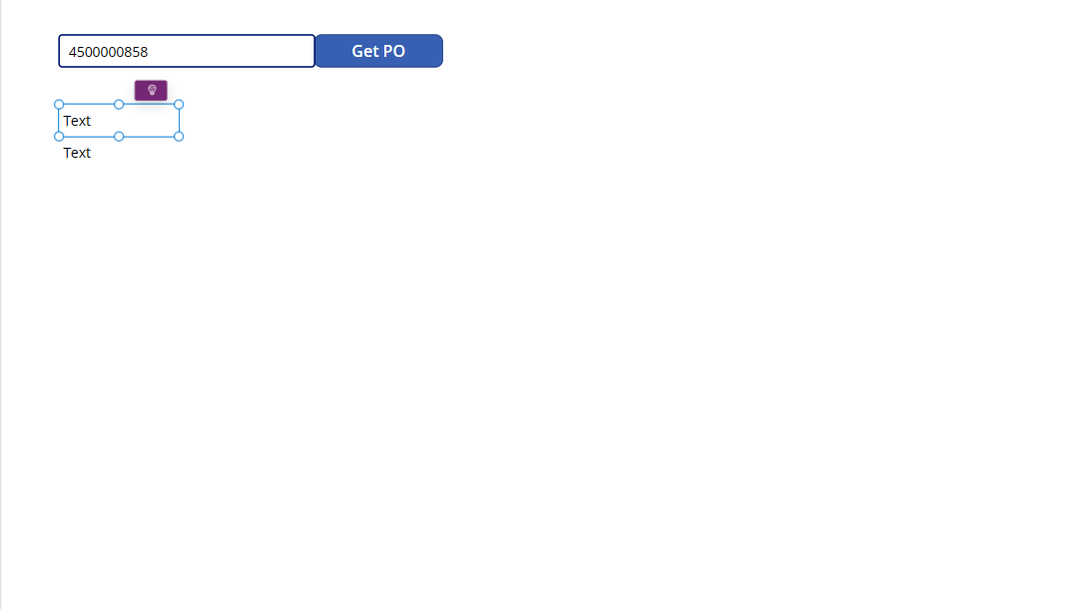

- Configure the Text Labels. We will make some property changes to the text labels to beautify the app. Select the top Text Label and make the following changes to the properties.
Text – “Order Type”
Font Weight- Bold
Alignment – Center
Font Color – White
Background Color – Black

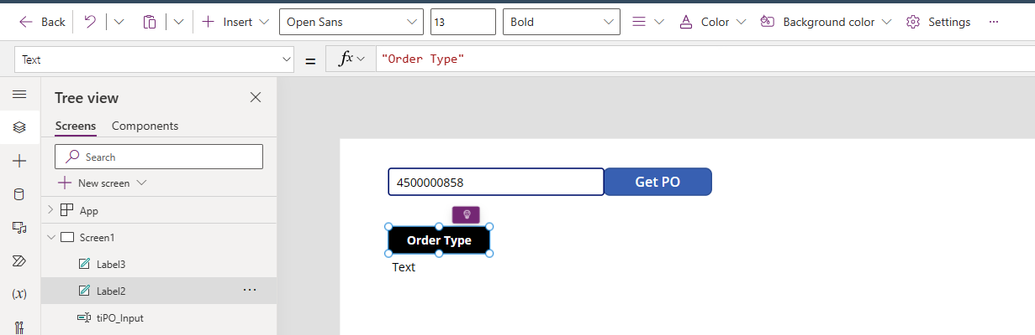

- Select the bottom Text label and make the following changes to the properties.
Text – POData.Header.OrderType
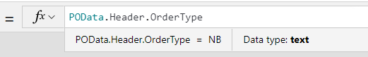
NOTE: This is our variable data from SAP. When you click on the period after Header, Intellisense will list the other data that is being brought back from SAP. You will also see the value of the data – “NB”.
In the right-hand properties, change Border Thickness to 2 and Text alignment to Center.
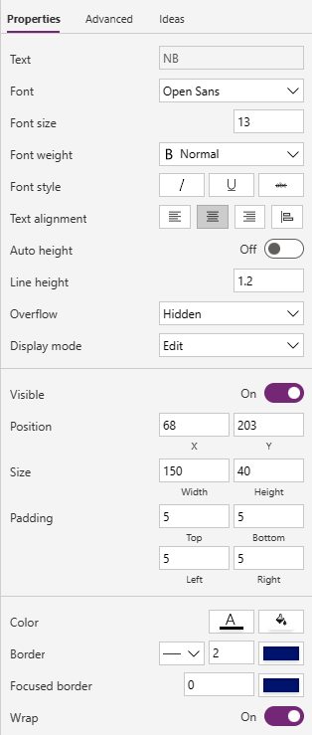
Once you have the border around the 2nd Text Label, line them up using the grid lines. Your canvas should now look like the screen shot below.
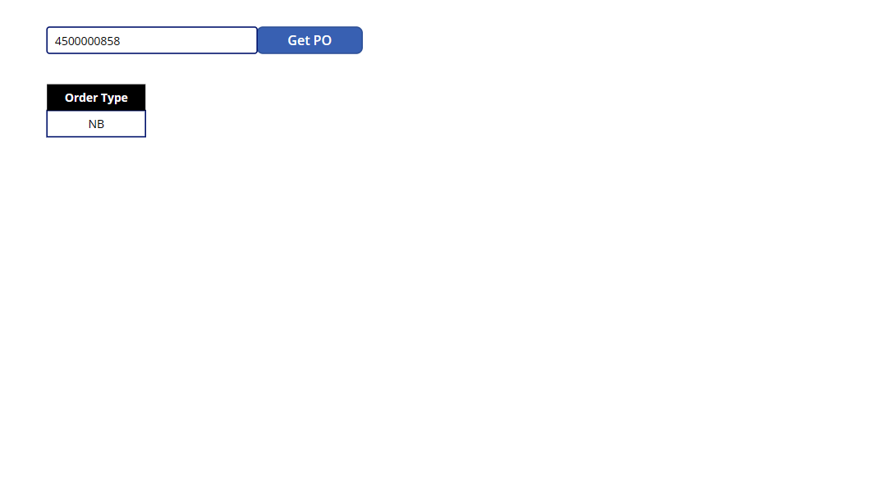

- Create 4 more columns of Text Labels for the rest of the date. Select both Text Labels and Ctrl-C to copy and then Ctrl-V to paste. Once you have copied the pair of labels, move them as a group so they line up horizontally on the canvas.

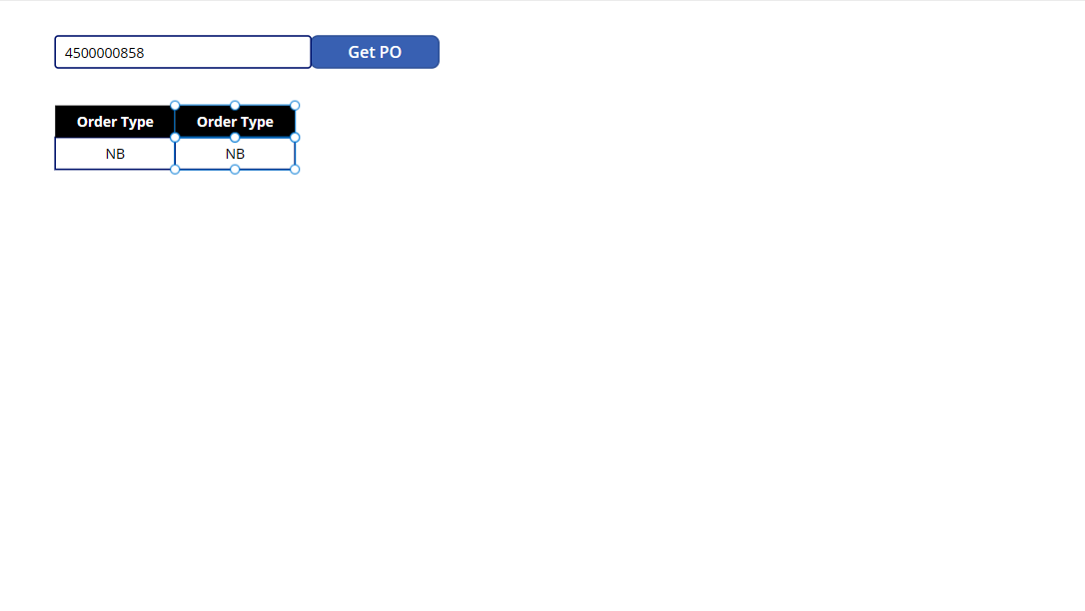

- Type Ctrl-V 3 more times so you have 5 sets of labels. Move the labels as pairs so the canvas looks like the screen shot below.
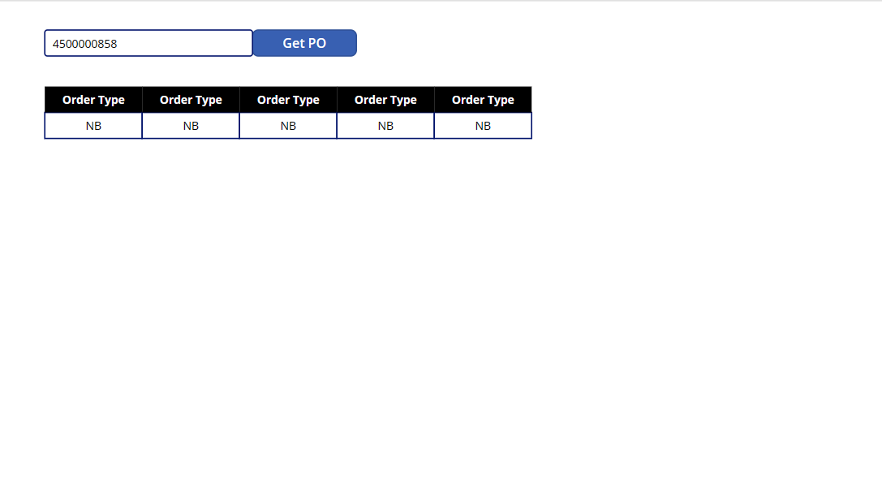

- Change the data of the columns to pull in the other PO Header data. Now we need to change that data for the other columns to reflect the other data fields coming back from the PO Header in SAP. Click on the 2nd header label to select it and change the Text to Purchasing Org.
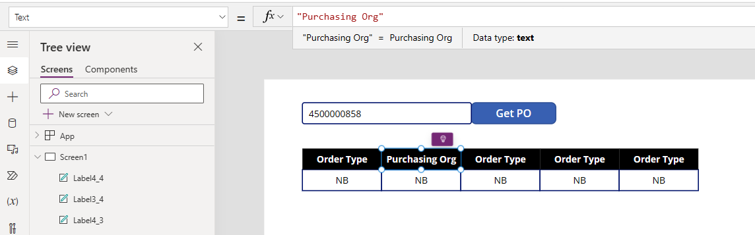

Follow the same steps for the other column headers using the text below:
Column 3 – “Vendor”
Column 4 – “Created By”
Column 5 – “Created Date”
Your canvas should now look like the screen shot below.
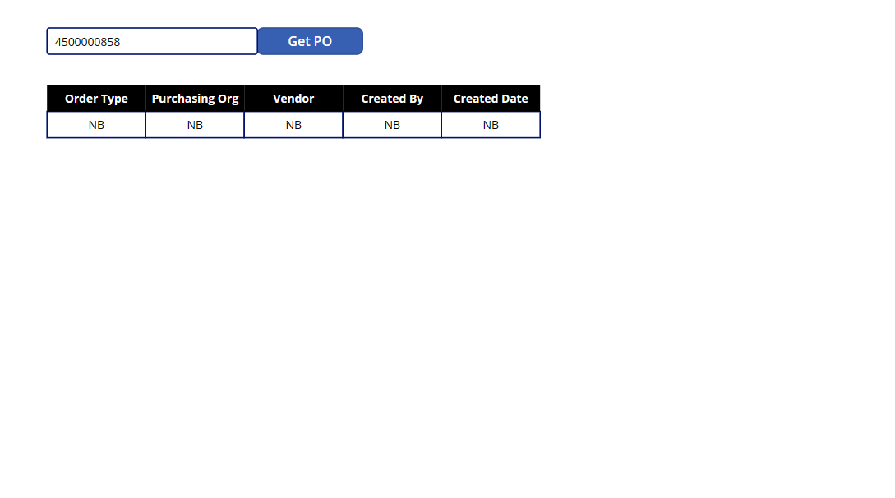
- Change the data fields. Currently all the data fields are set to OrderType, so we need to change that to reflect the correct data field for that column. Click on the Purchasing Org data field to select it. Change the text to POData.Header.PurchasingOrganization.

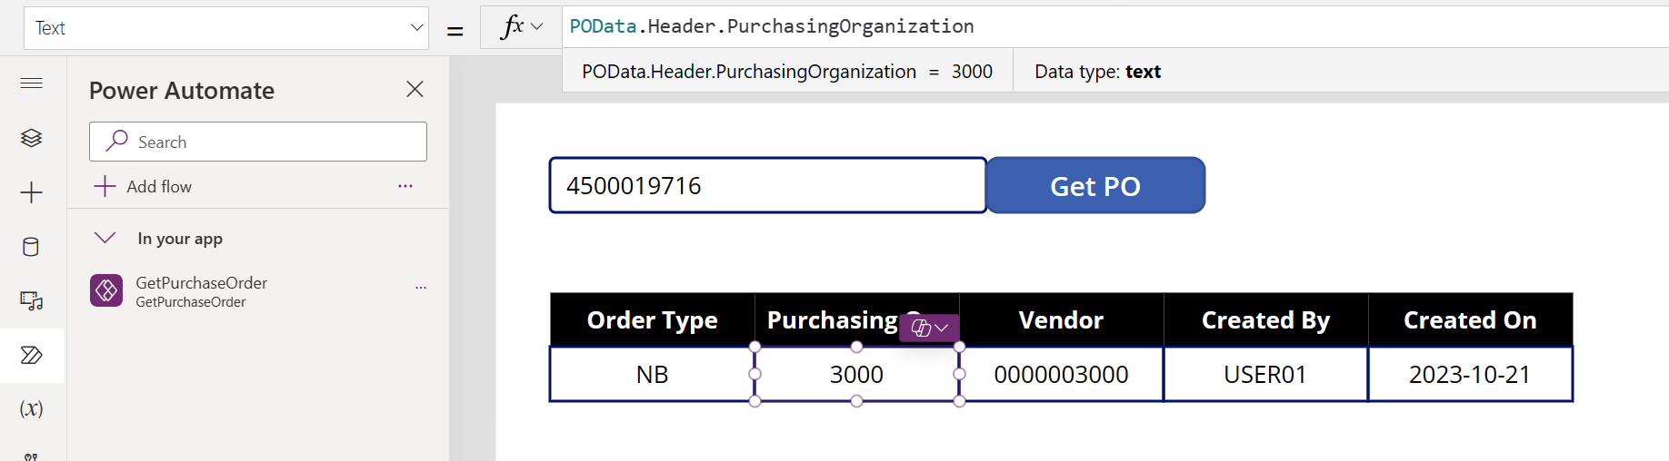

Follow the same steps to change the other data fields using the text below:

Vendor – POData.Header.Vendor
Created By – POData.Header.CreatedBy
Created Date – POData.Header.CreatedDate

Your canvas should now look like the screen shot below.

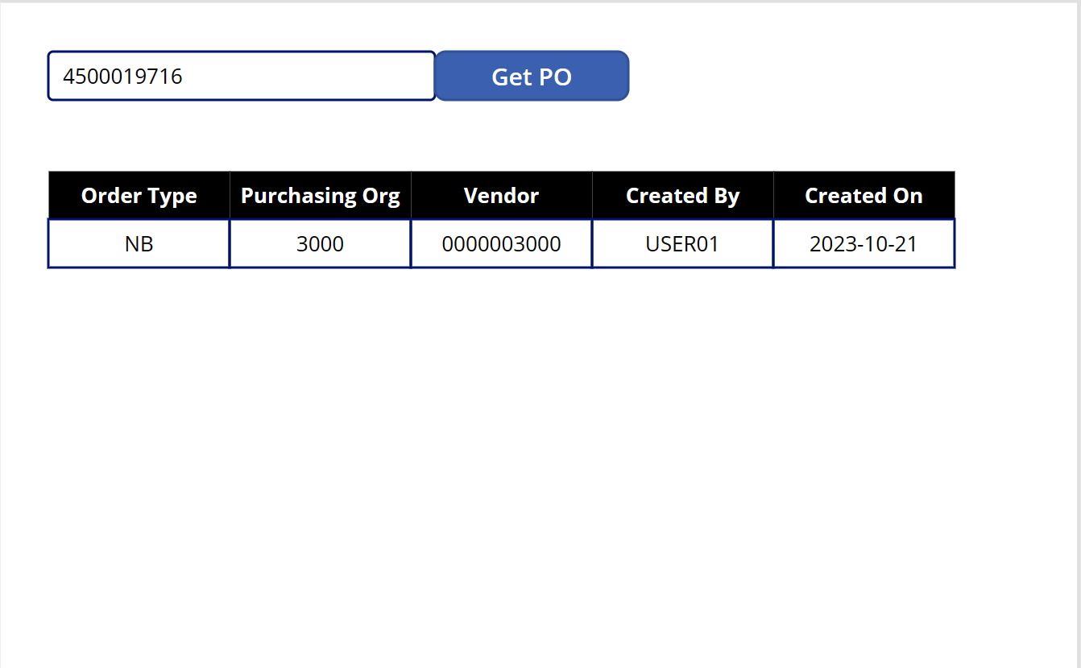

- Save the App. Click on the Save icon in the upper-right hand corner.
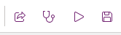

Exercise 13: Shape the data returned from SAP

We are now going to shape the data being returned from SAP. Many times, the data is not in the format we need to use or there is too much data, and we need to only pass a limited set of data.
Below is a table of the most common Data Operations that you may be using to manipulate data from SAP.
Action Name | Description
Compose | Use the Compose action when you need to enter data multiple times in a cloud flow – for example creating an array. Use with another operation like Join to access the contents.
Join | Use the Join action to delimit an array with the separator of your choice. For example, change an array separated by commas to be separated by semicolons.
Select | Use the Select action to transform the shaped of objects in an array. For example, you can add, remove, or rename elements in each object in an array.
Filter Array | Use the Filter array action to reduce the number of objects in an array to a subset that matches the criteria you provide.
Create CSV Table | Use the Create CSV table action to change a JSON array input into a comma-separated value (CSV) table.
Create HTML Table | Use the Create HTML table action to change a JSON array input into an HTML table.

For more detailed information on the Data Operations and specific examples, please refer to this document - Use data operations in Power Automate (contains video) - Power Automate | Microsoft Docs

    - Pass back the PO line item details from SAP. We will now manipulate the line item details into an array so we can name the data to something that makes sense and only pass back the limited amount of data we need. Click back on the tab that is editing your Power Automate flow – GetPurchaseOrder. You may need to click Edit again.

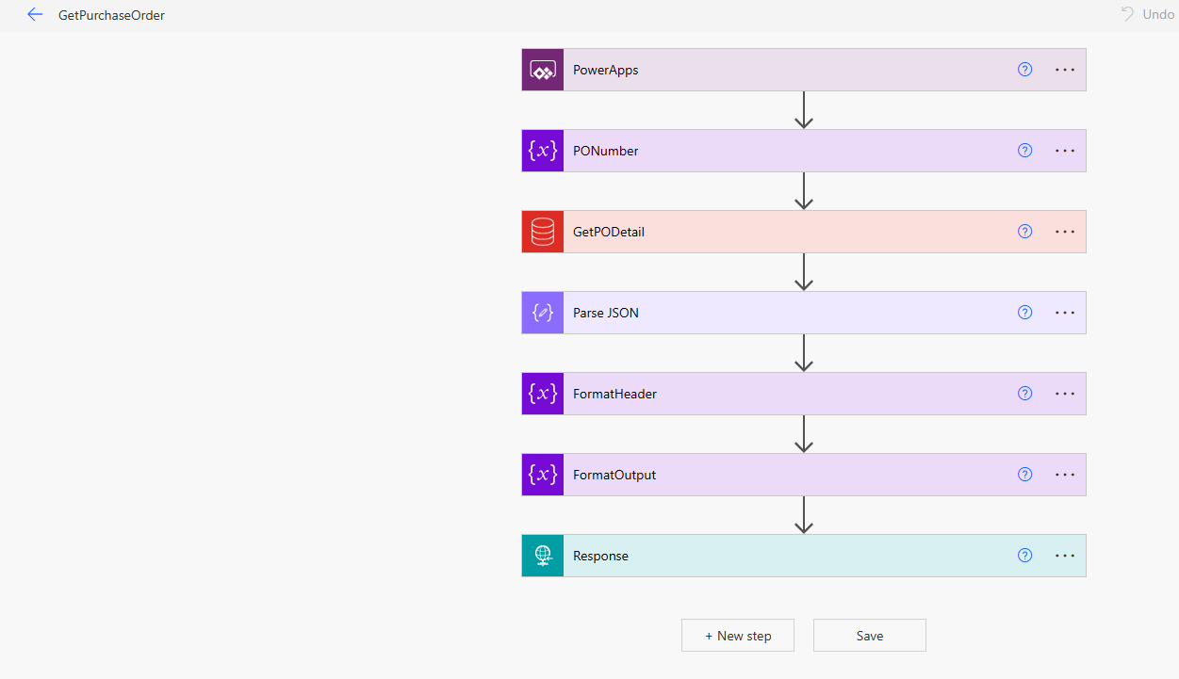

- Add a new step after the FormatHeader action. Mouse over the arrow between the FormatHeader action and the FormatOutput action to add a new step.
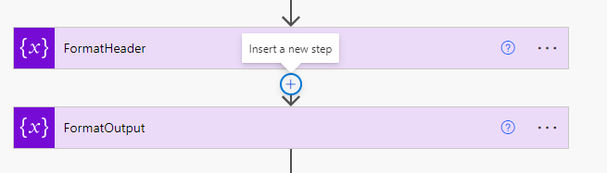

- Click on the + to add a new step and then Add an action.

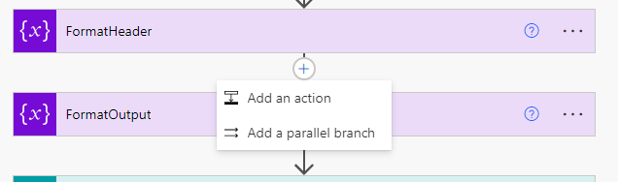
- We will use the Select action to format the elements of the array. Type in Data Operations in the search box and select Select – Data Operations action.
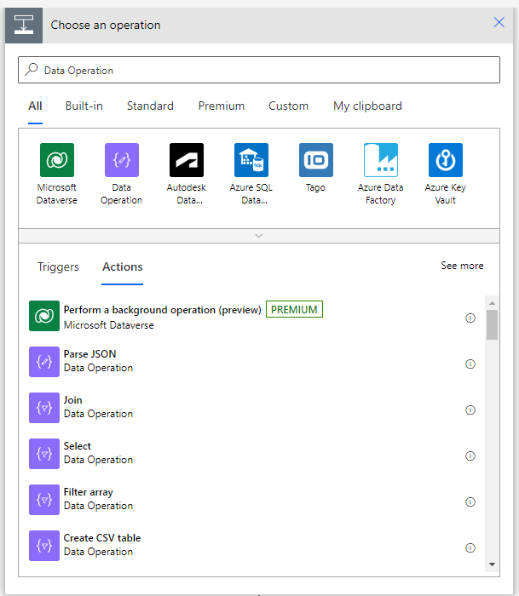

- Rename the Select Action. Click on the ellipse (...) and then Rename. Rename the action FormatItems.
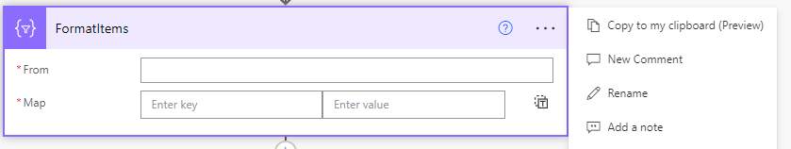
- Configure the Select Action. Click in the From box. Search for POITEM in the Dynamic Content and select POITEM from the Parse JSON action. Do not select PO_Item or you will get a conditional loop.

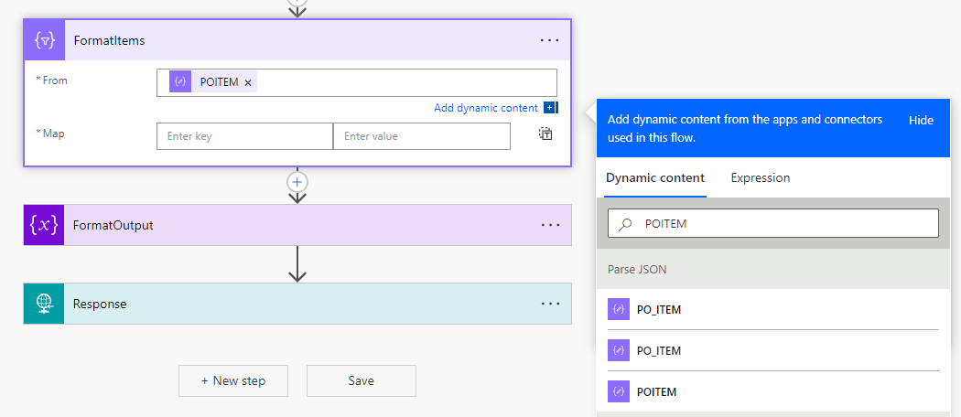

- We will now create a map to bring back only the data we need and with a data key that will be more recognizable in Power Apps. Click in the Map section and enter the following Key and Value pairs for the map using Dynamic Content for the Value. Use search to find the values more easily and pull from the Parse JSON action.
Key | Value
ItemNumber | PO_ITEM
Material | MATERIAL
Description | SHORT_TEXT
Quantity | QUANTITY
Unit | PO_UNIT
UnitPrice | NET_PRICE

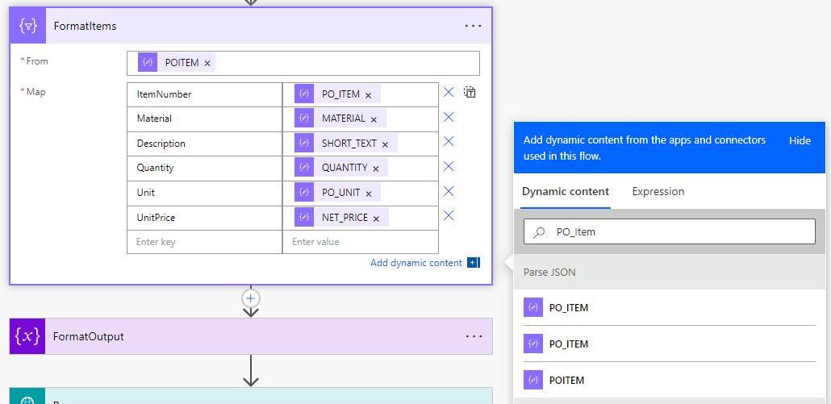

- Create a calculated field for the Total Price field. We will now use an Expression to create a calculated field that adds up total of this line item. We will calculate this by multiplying the NetPrice by the Quantity. Since SAP values are coming back as Text values, we will need to convert them to numeric values.
Back in our Map Table, type in TotalPrice in the Key Field. Click in the Value field and select Expression from the Dynamic Content. Paste the formula below into the formula bar and then click on Okay.
formatNumber(mul(float(item()?['QUANTITY']),float(item()?['NET_PRICE'])), 'F2')
This expression multiples Quantity by NetPrice. Float converts the string to a number and FormatNumber at the beginning of the formula and F2 at the end of the formula format the TotalPrice to have 2 decimals.
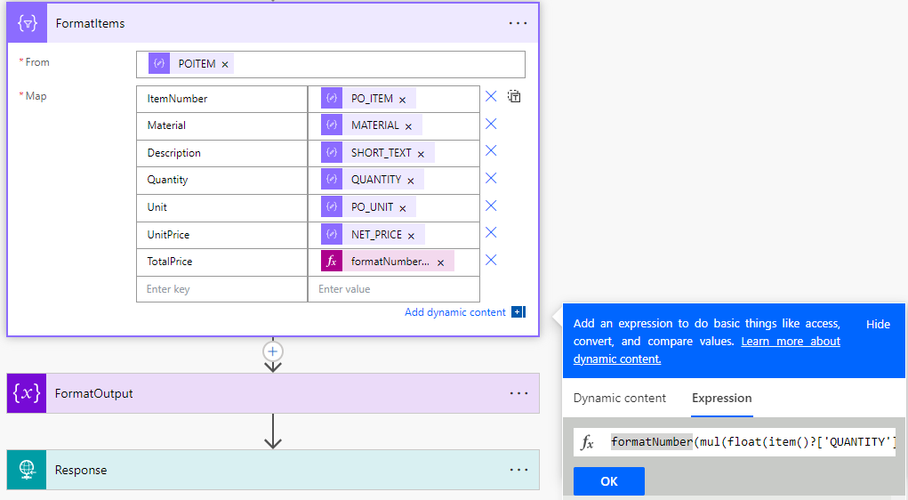

- Save the Flow and Test with a Manual Trigger.
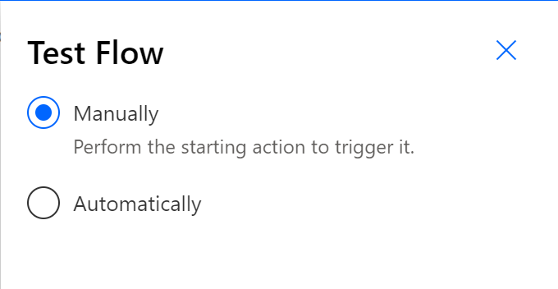
Enter 4500019716 for the PO number.
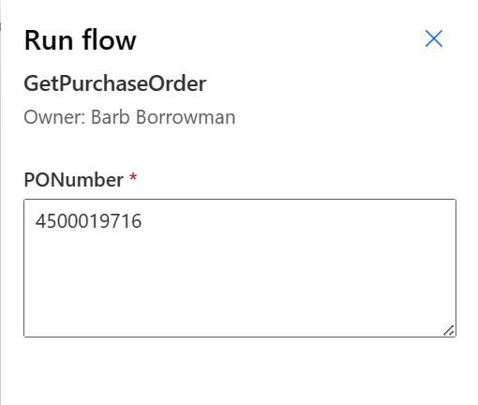

- Verify the data is being pulled back properly and our calculated field is correct. Expand the FormatItems action and scroll through the Outputs section.

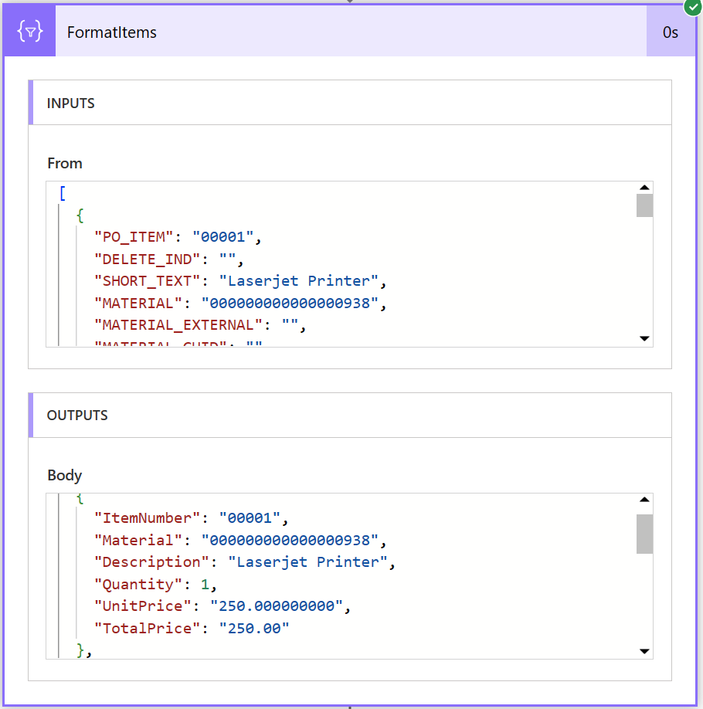

- Update the schema for the FormatOutput section to include the Format Items data. Click on Edit. Expand the FormatOutput action. In the value section, make the following changes.
- Add a comma behind the name/value pair and then enter
- On the next line type “Items”: Output – where Output is from Dynamic Content under FormatItems
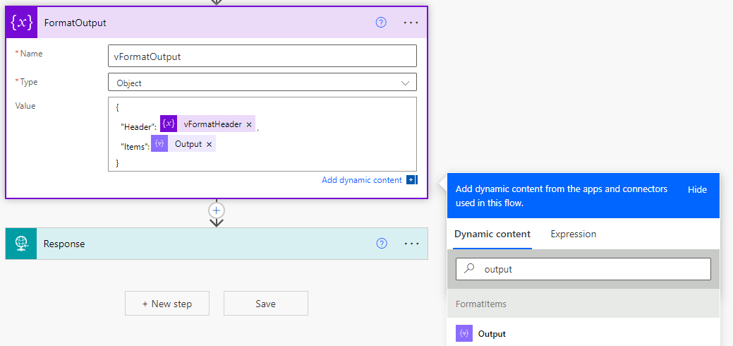

- Add the PO Number directly into the FormatOutput by adding a simple name/value pair. In the Value section, add a comma behind the Items name/value pair to add another set of data and hit enter. On the next line, add the following text:

“Order”: PO_NUMBER – where PO_NUMBER is from Dynamic Content under Parse JSON action.

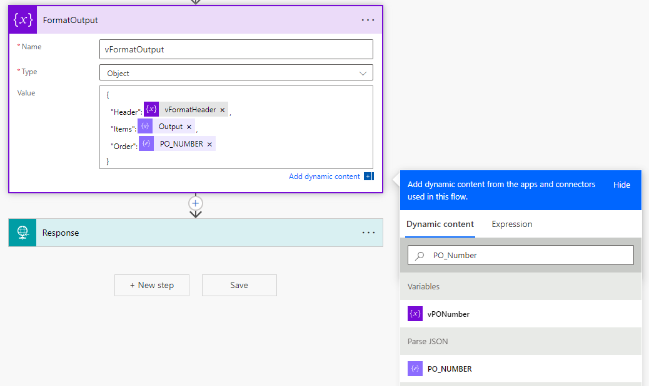

- Update the Response Section. We now need to get the new schema from the FormatOutput action and generate from sample to create the new schema like we have done several times already.
  - Save and Test the flow using an automatic trigger.
  - Expand the FormatOutput action and copy the entire Value section.
  - Edit the flow.
  - Expand the Response action.
  - Click on Advanced Options.
  - Click on Generate from sample
  - Paste the new schema
  - Save the flow

- Update the Power App to show our item list and PO number. Click back to your tab where you are editing your Power App. First, we need to update our Power Automate flow since we have made changes. Click on the Power Automate tab in the tree on the left-hand side. Click on the ellipse (…) and then Refresh.
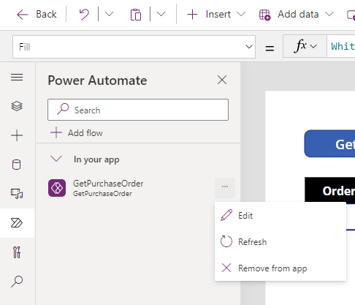

- Play the app to load in the new data. Another way to play the app inside the canvas is to hold down the Alt-key and then click on the GetPO Button. This will cause the cloud flow to get the new line item and PO number values.
If needed, use PO # 4500019716.

- Add the PO Number to the App. We will use Ctrl-C to copy the OrderType Text label and OrderType Value field to make things easier. Ctrl-V to paste them on the canvas. Drap and Drop them above the POHeader information.
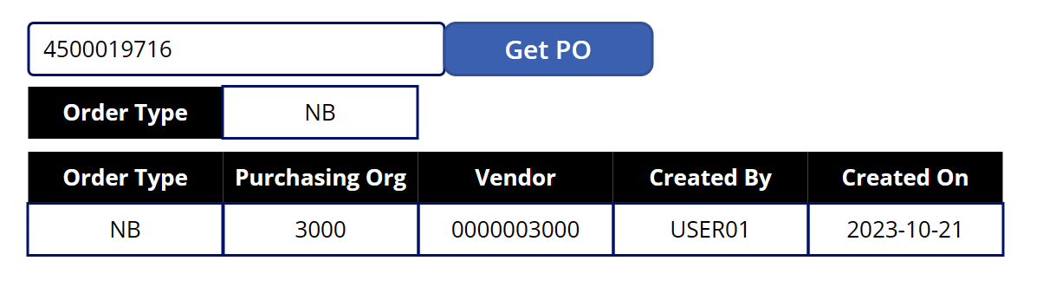
- Update the fields to display the PO number data. Click on the new OrderType Header to select it. Update the Text to “PO Number”
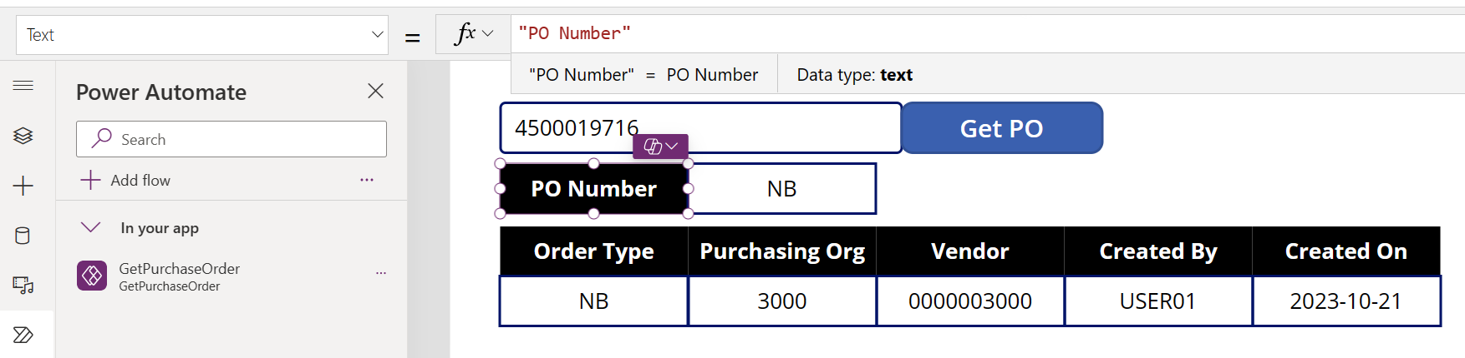

Click on the new Text Order Type value field to select it. Change the Text formula to POData.Order. We don’t need to have Header in the formula.

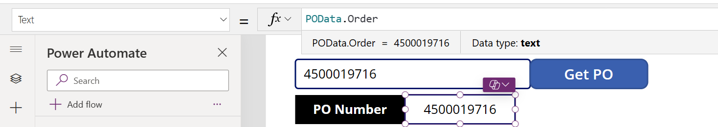

- Insert the Line Items into the Canvas App. Click on Insert and select Blank Vertical Gallery. You may have to expand the Layout section to find it.
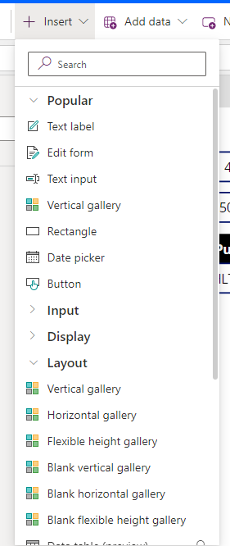
Drag and drop the gallery below your PO Header information and leave room for column labels above and a total row below.

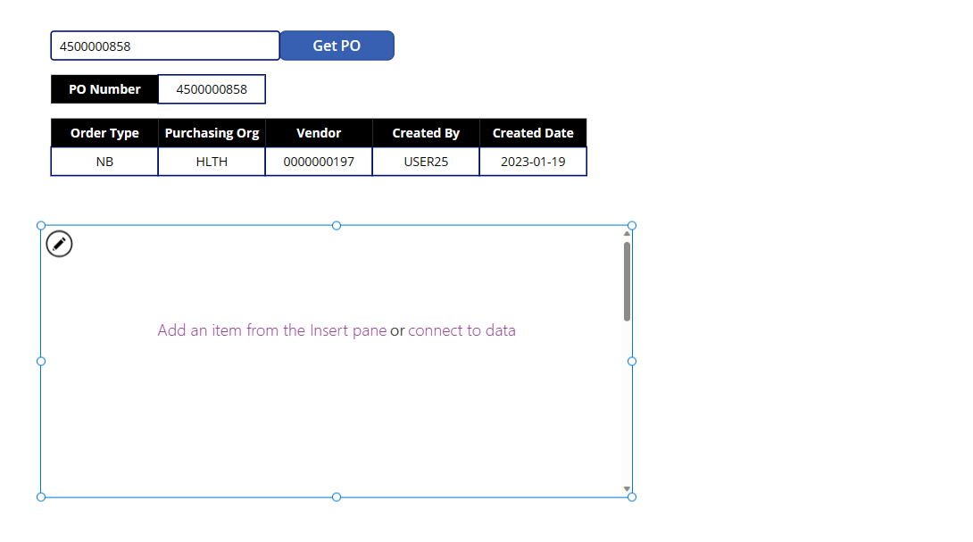

- Change the Items formula to point to the Line Items data by changing the text to POData.Items
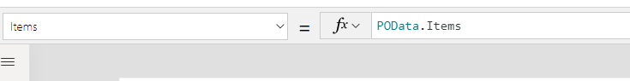

- Configure the Gallery. We need to add the fields we want to display in the gallery. With the Gallery still selected, click on Insert and then Text Label. Power Apps will bring in what it thinks you may want for the first item. It brought in the Description field.
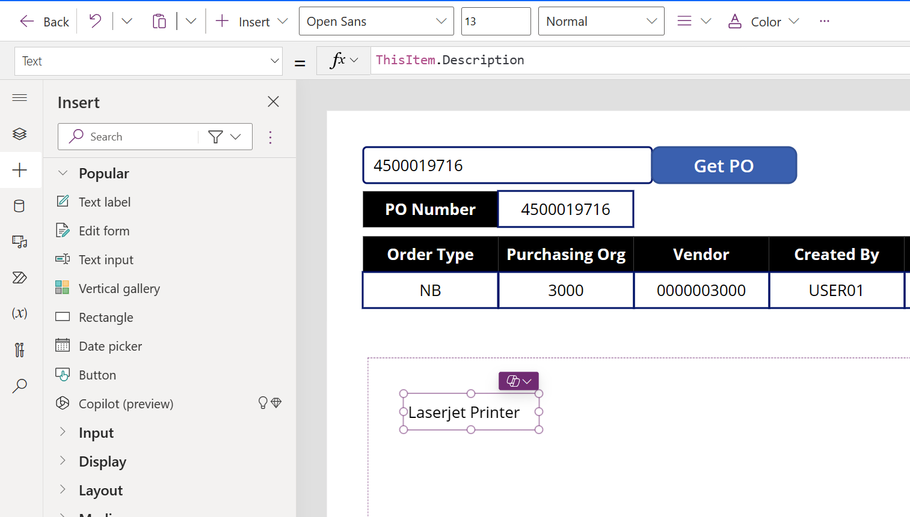
Drop and drag to the middle of the gallery.
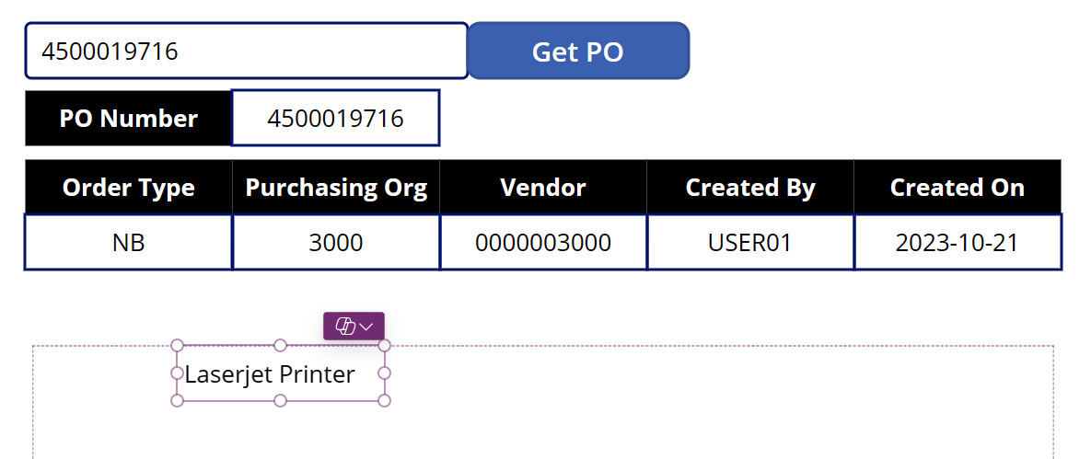
- Repeat the previous step six times to bring in all the data fields listed in the table below and have the columns in the same order of the screen shot below.
If the short cut does not bring in all the fields for you like Quantity, select the Text Label and then set the Text formula to match the table below. You can reduce the size of the Quantity and Unit fields.

Item | Text Formula
Item Number | ThisItem.ItemNumber
Quantity | ThisItem.Quantity
Unit | ThisItem.Unit
Description | ThisItem.Description
Material | ThisItem.Material
Unit Price | ThisItem.UnitPrice
Total Price | ThisItem.TotalPrice

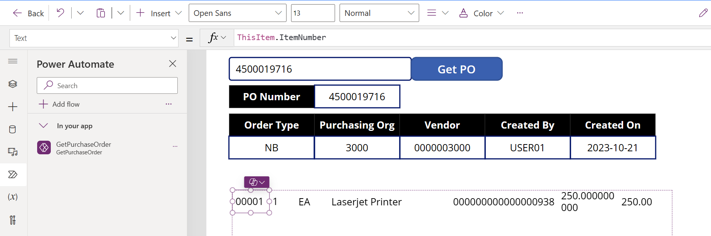
- Format the Unit Price and Total Price fields. Change the format of the unit price field to only have 2 decimals. Select the Unit Price field and then change the Text formula to:
Text(Value(ThisItem.UnitPrice),"##,###.00")

Repeat the same process for Total Price field.
Text(Value(ThisItem.TotalPrice),"##,###.00")

- Create Headers for our Line Item Gallery. A quick way to create headers for all the columns in the gallery is to select all the labels in the gallery and then Ctrl-C to copy them.
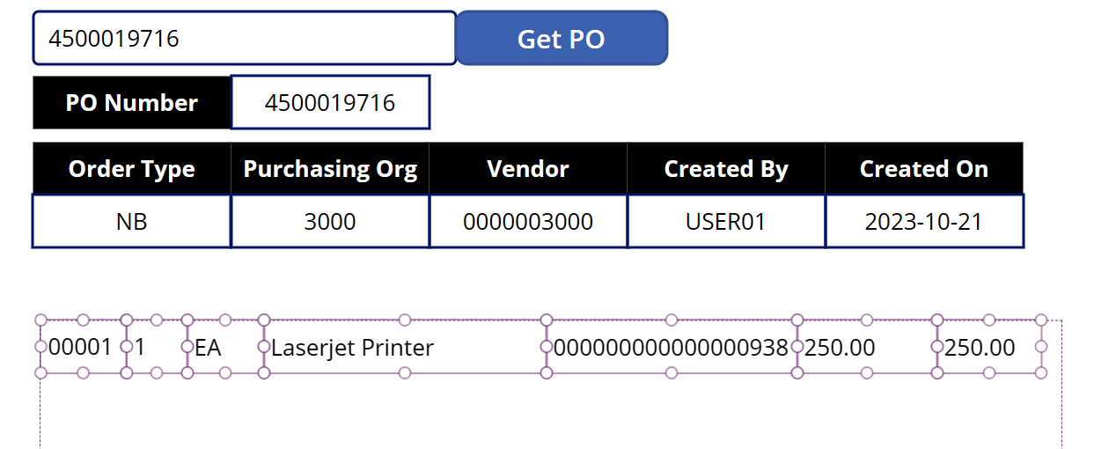
- Paste the labels. Click outside the gallery, click Ctrl-V to paste and then drag and drop them as a group to line up above the line item gallery.
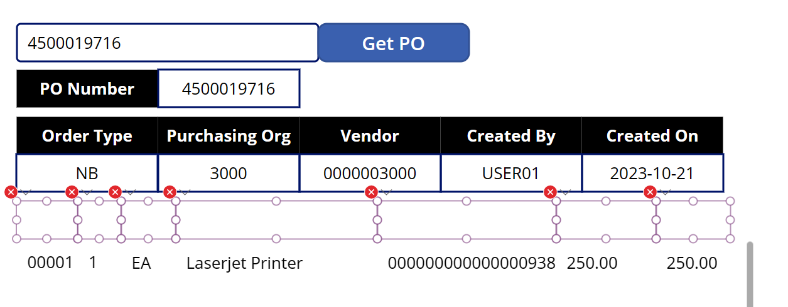
- Configure the Header Labels. Clear out the OnSelect formula. Keeping all the labels selected, scroll down to the On-Select property in the property drop down list and delete Select (Parent). This removes the link to the data.

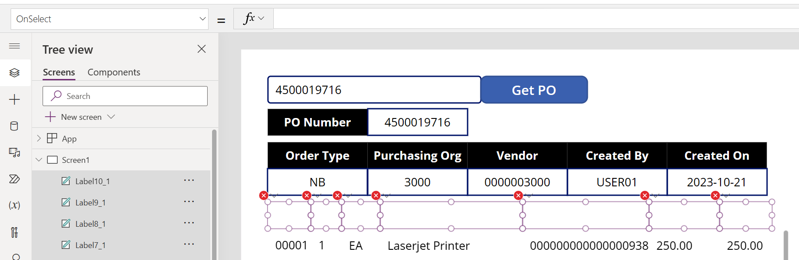

- Individually select each header label and set the Text Property based on the table below:
Tip: If you click on the red x  and then select Edit in the formula bar, it will bring you directly to the Text Property for that label.
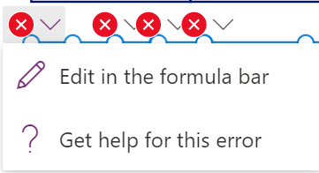

Header Name | Text Property
Item Number | “Item No”
Quantity | “Qty”
Unit | “U/M”
Description | “Description”
Material | “Material”
Unit Price | “Unit Price”
Total Price | “Total Price”

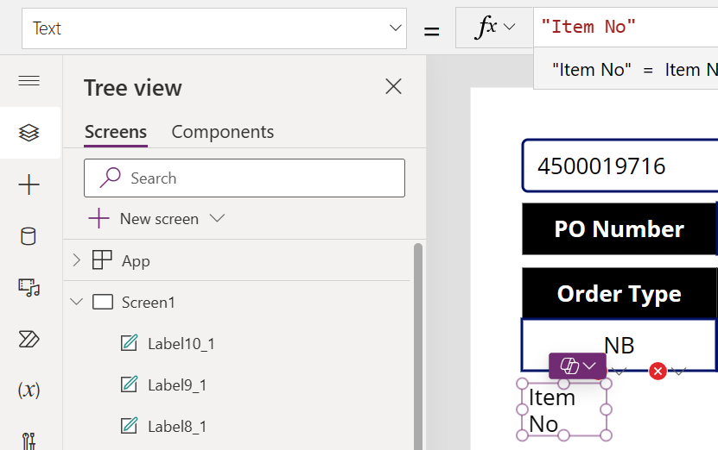
- Select all the header labels again and change the following properties:

Font Weight – Bold
Text Alignment – Center
Text Color – White
Text Fill – Black

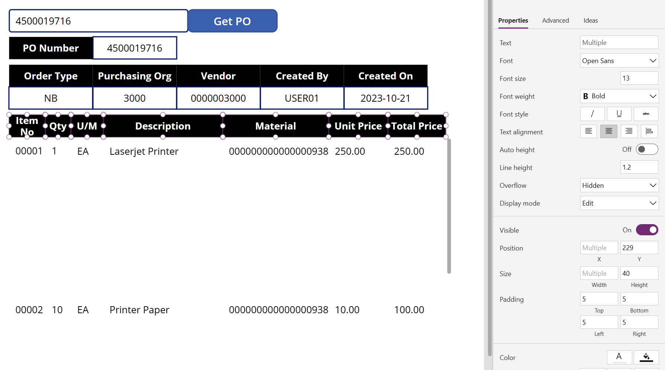

- Configure the Gallery. Select the gallery and reduce the size of the gallery so we can add another text label for total at the bottom of the screen.

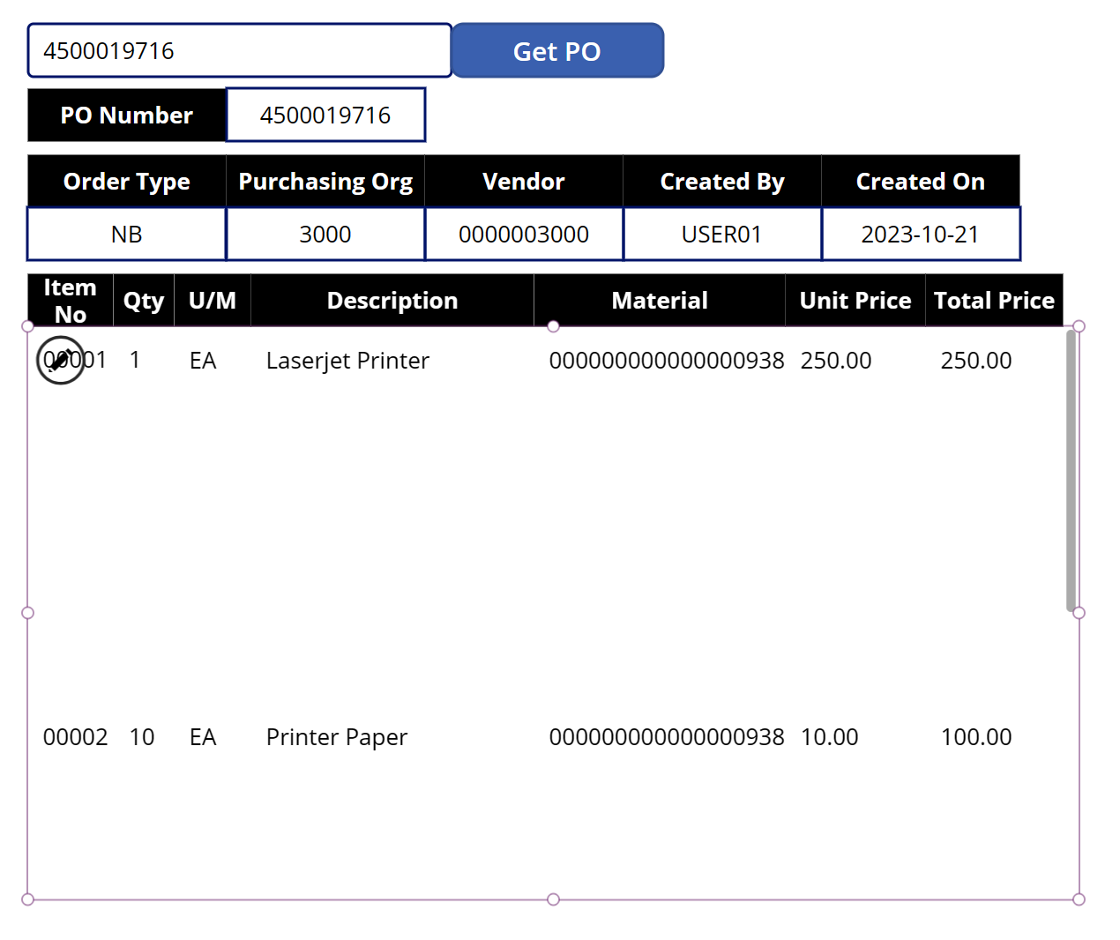

- Add a border around the gallery. On the properties on the right-hand side, change border to 2.
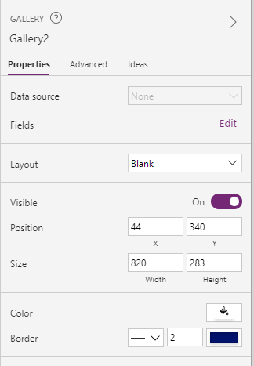
- Reduce the size of the template cell. Click on the pencil icon in the gallery to edit the template cell.
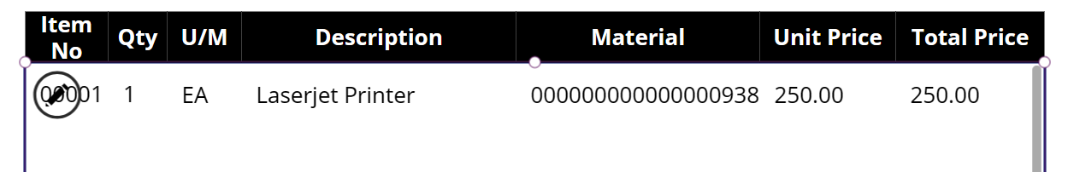

Reduce the size of the template cell. This will be the size of each row in the gallery so we can have multiple rows showing on the screen.

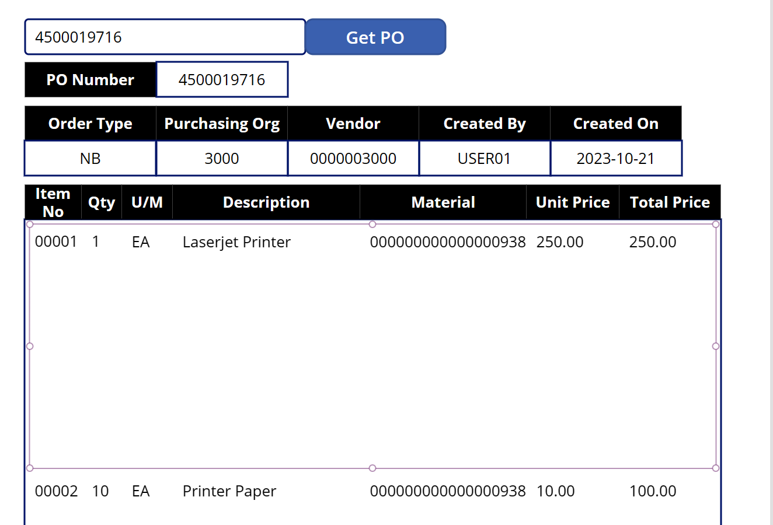
- Add Text Labels for Total Price of Invoice. Click outside the gallery to unselect it. Click on Insert then Text label. Repeat so you have (2) new text labels.

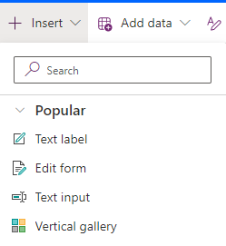
- Drag and drop the new text labels under the gallery on the right-hand side.

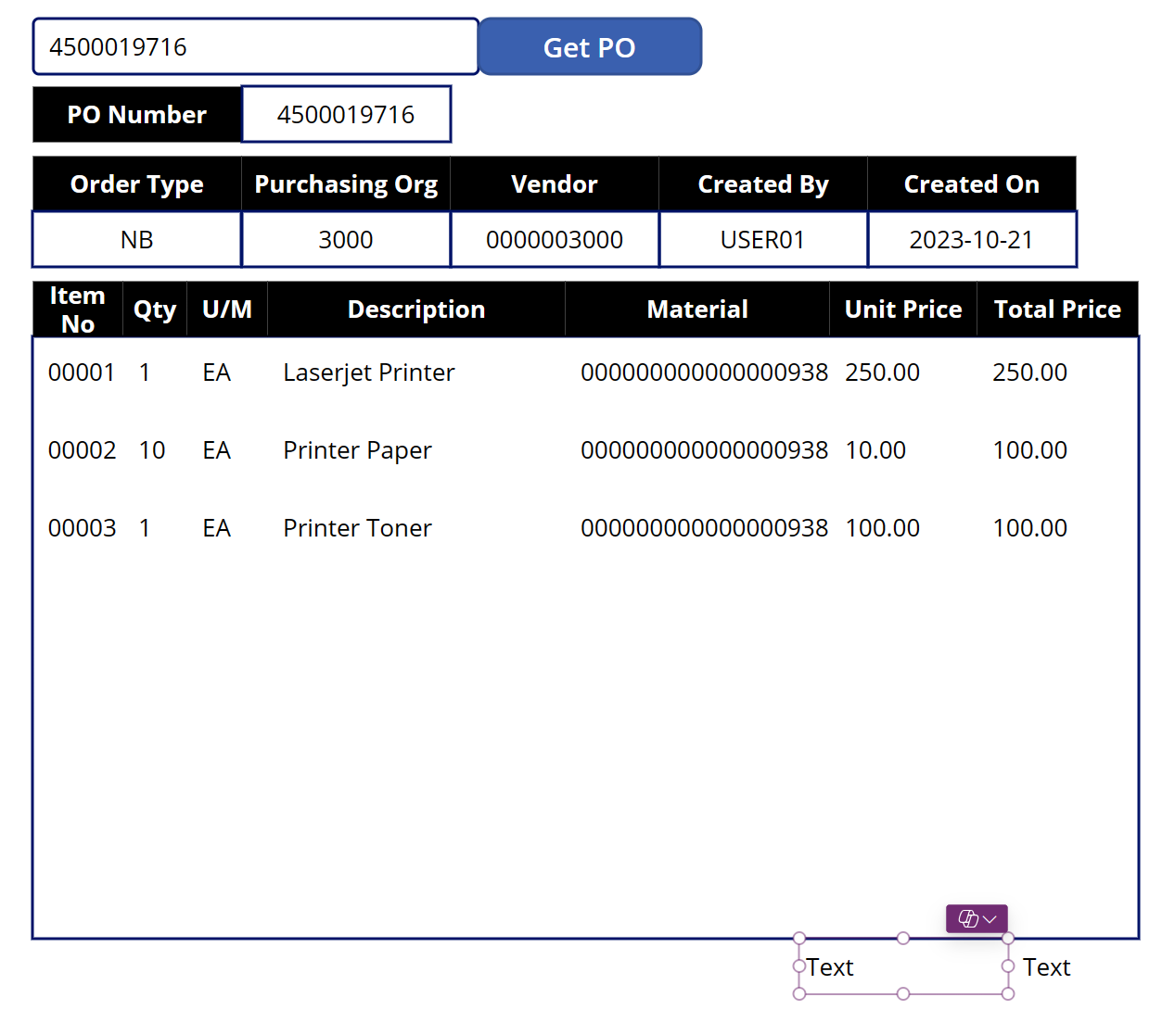

- Configure the text labels. Change the Text Property for the new labels as follows:
Text Box 1 – “PO Total:”

Text Box 2 – Text((Sum(Gallery1.AllItems,TotalPrice)),"$##,###.00")

If you get an error message when you paste, try typing in the formula using Intellisense.

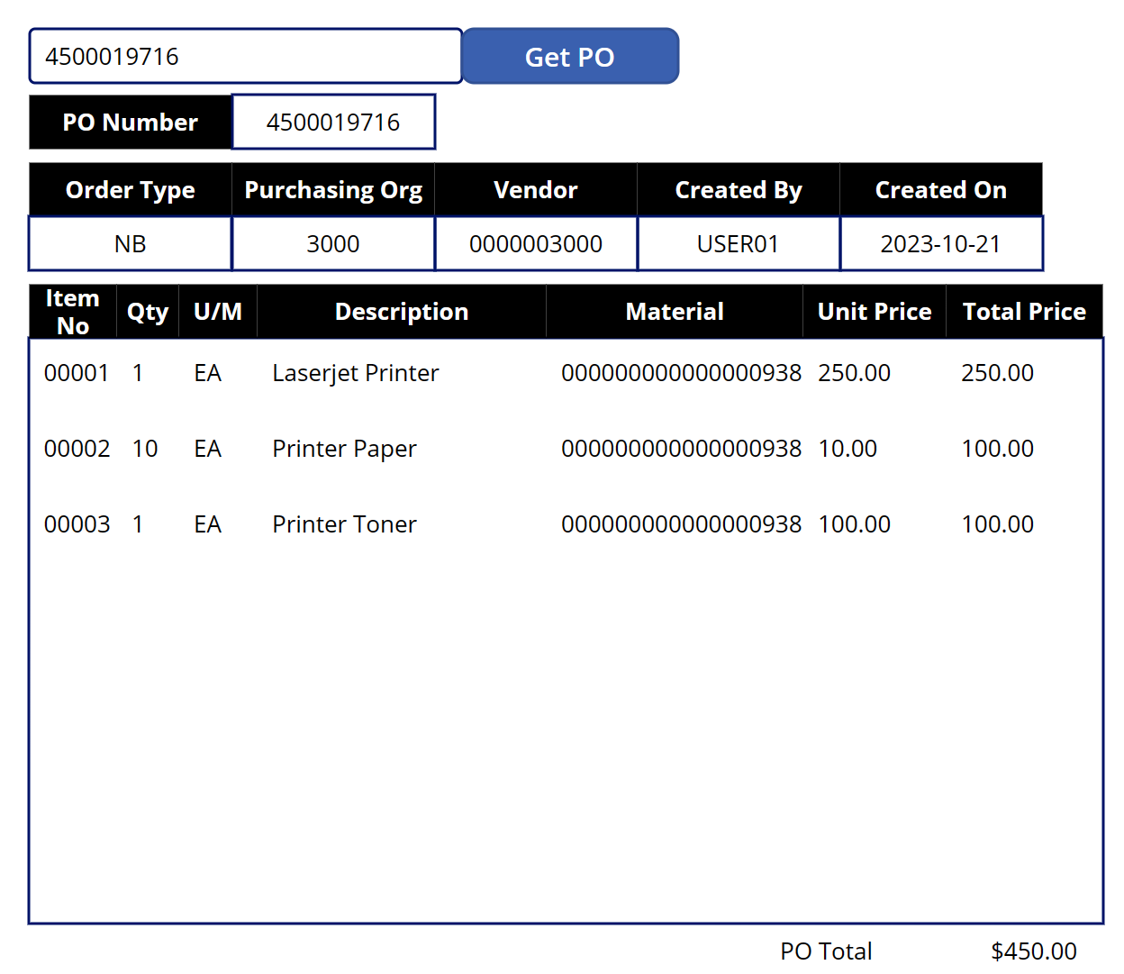

- Save your app.

Congratulations on completing this app that retrieves PO information from SAP!

Exercise 14: Embed Power App into Teams (OPTIONAL )
We will now embed your newly created app in Teams.
Embed a canvas app as tab app - Power Apps | Microsoft Learn
Embed an app in Teams - Power Apps | Microsoft Learn
- Back out of your canvas app by clicking on the Back arrow in the upper ribbon or if you are just starting the labs again, you want to be in your SAP Workshop – XX solution.

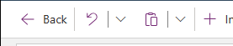

- In your solution, select the 3 dots of the PurchaseOrderViewer canvas app and then click on Add to Teams.
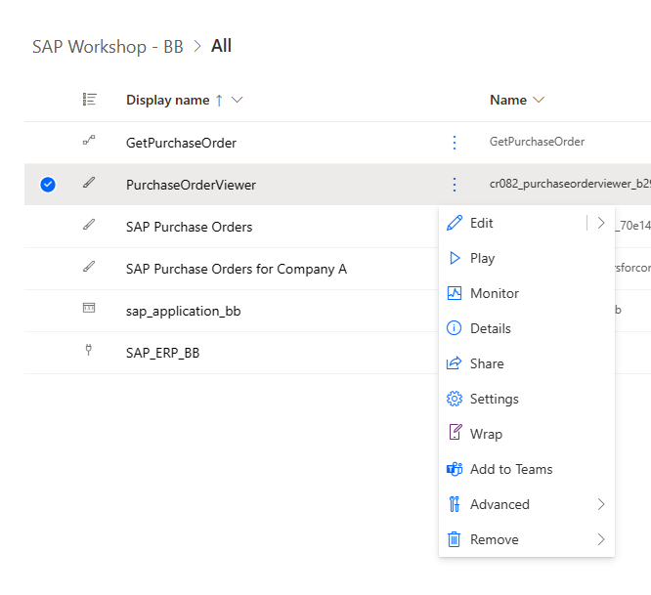
- Review the app details and then click on Add to Teams. 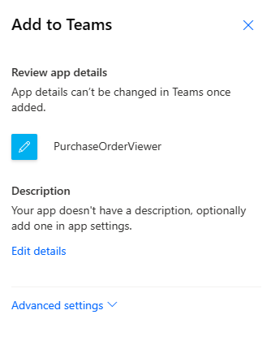
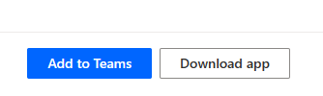
- This will attempt to open the Teams app which will be using your standard credentials. Click on Cancel and the Use the web app instead.

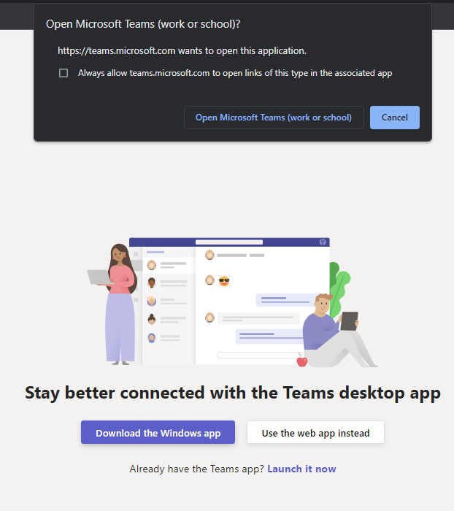

- Teams should open up on a new browser tab with the specific app you are trying to load. Click on Add.
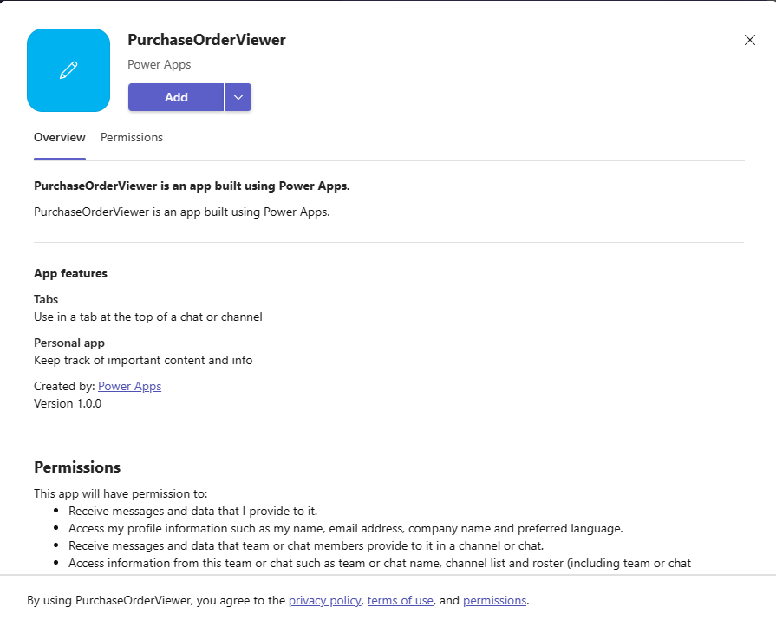
- You should now have the PurchaseOrderViewer app in your left-hand app menu.

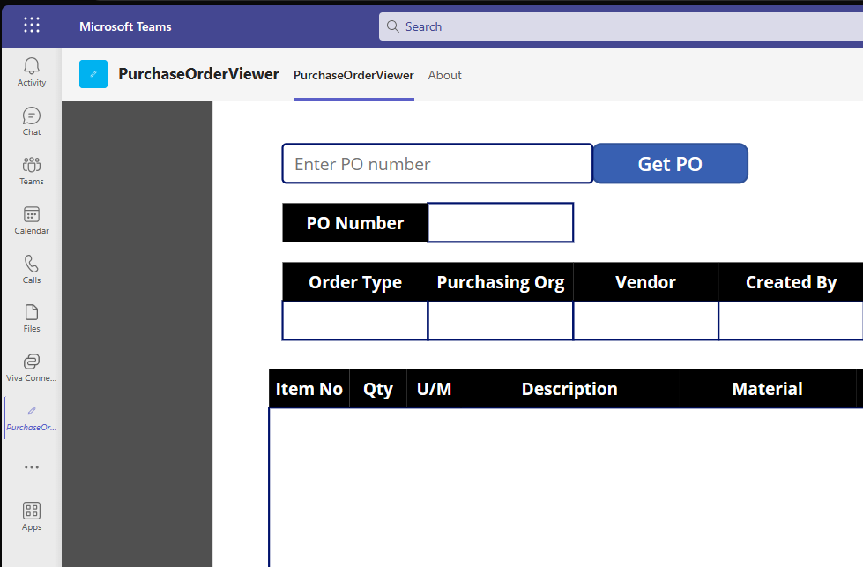

- If the pop-up did not appear, click on Apps in the left-hand navigation and then Manage your apps at the bottom of your left-hand ribbon and click on Upload an app.

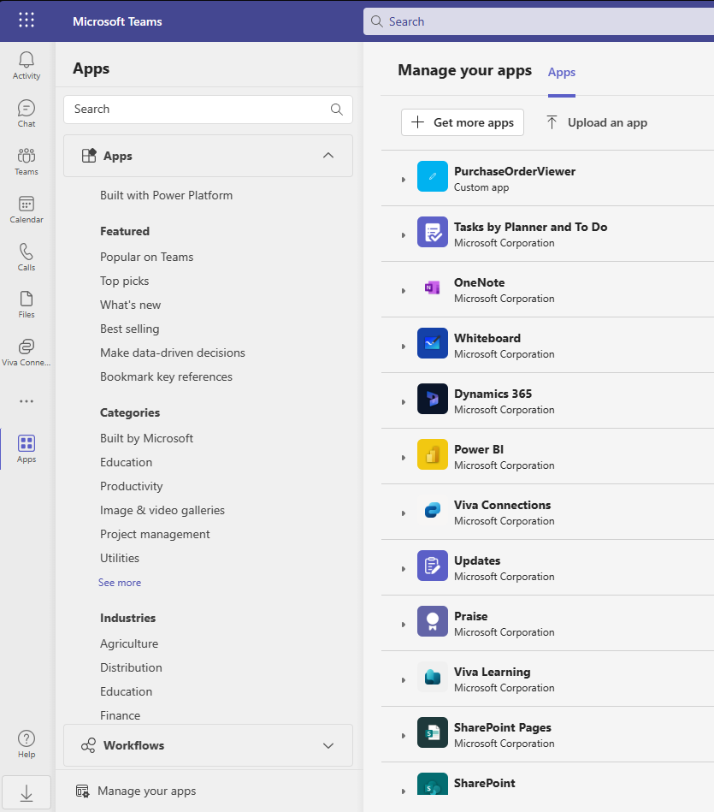

- Select Upload an app to your org’s app catalog and select the zip file from your Downloads folder.
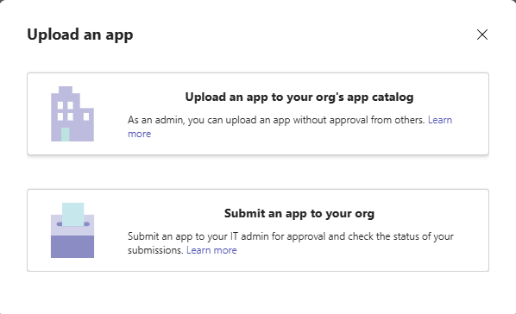
- Click on Add to add to your apps.
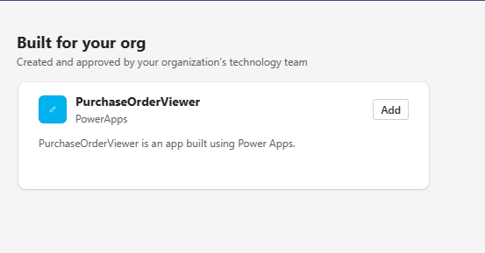
- Click on Add for the PurchaseOrderView app.

- The application should now show up in your apps in the left-hand navigations.

